Sahithi_siddamsetty_devops_936.
2.
program to print numbers from one to ten

#!/usr/bin/bash

for (( num=1;num<=10;num++))

do
echo " number is :$num"

done
output:
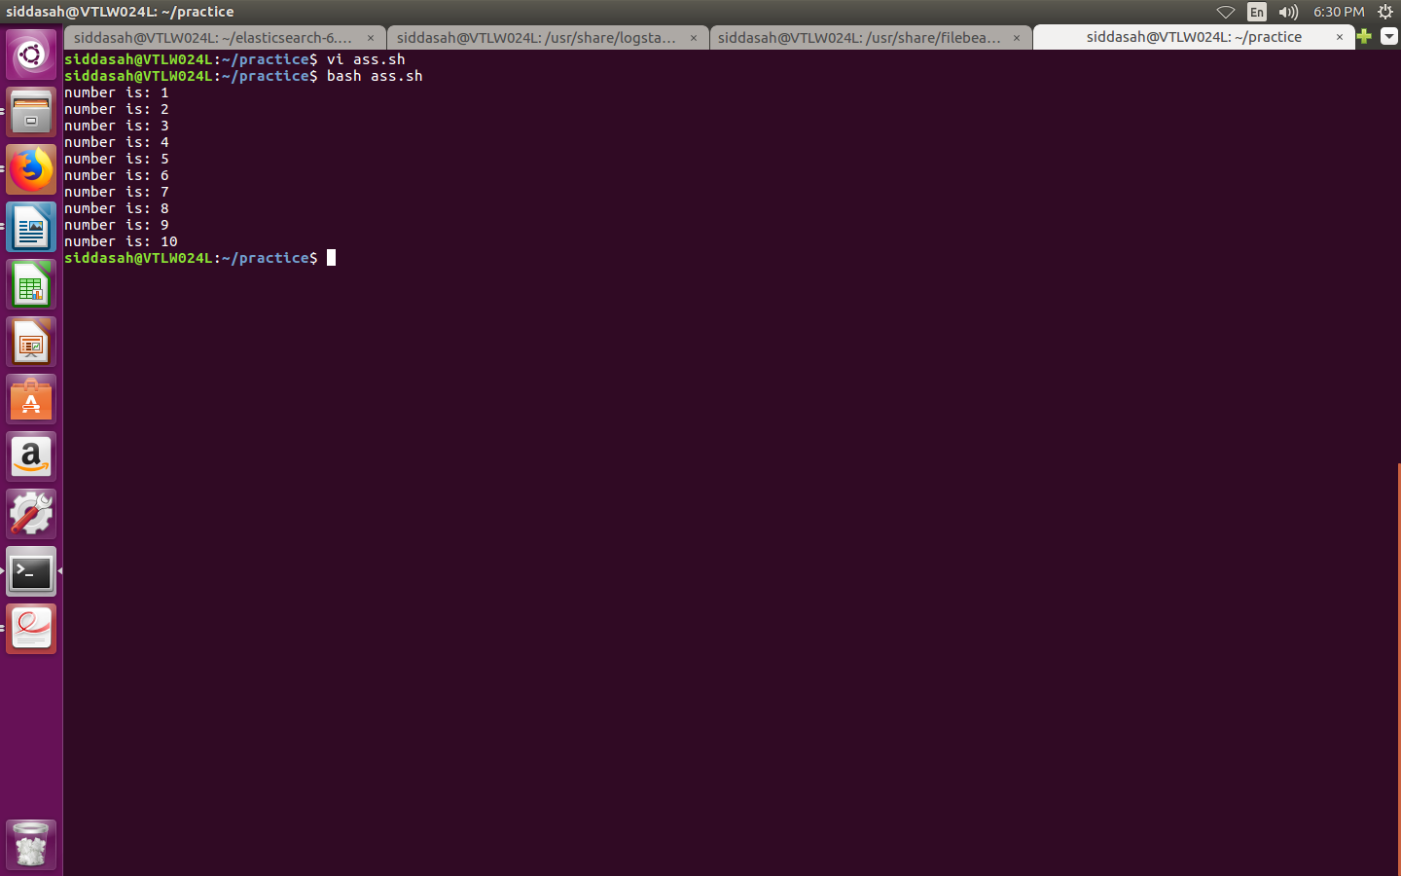
:

1.
caluculator program using switch

echo "enter values:"
read v1
read v2
echo "choose arithmetic operations: 1.sum 2.sub 3.mul 4.div 5.rem"
read opt
case $opt in
1)echo sum=`expr $v1 + $v2`
echo $sum
;;
2)echo sub= `expr $v1 - $v2`
echo $sub
;;
3)echo mul=`expr $v1 \* $v2`
echo $mul
;;
4)echo div=`expr $v1 / $v2`
echo $div
;;
5)echo rem=`expr $v1 % $v2`
echo $rem
;;
esac
output:
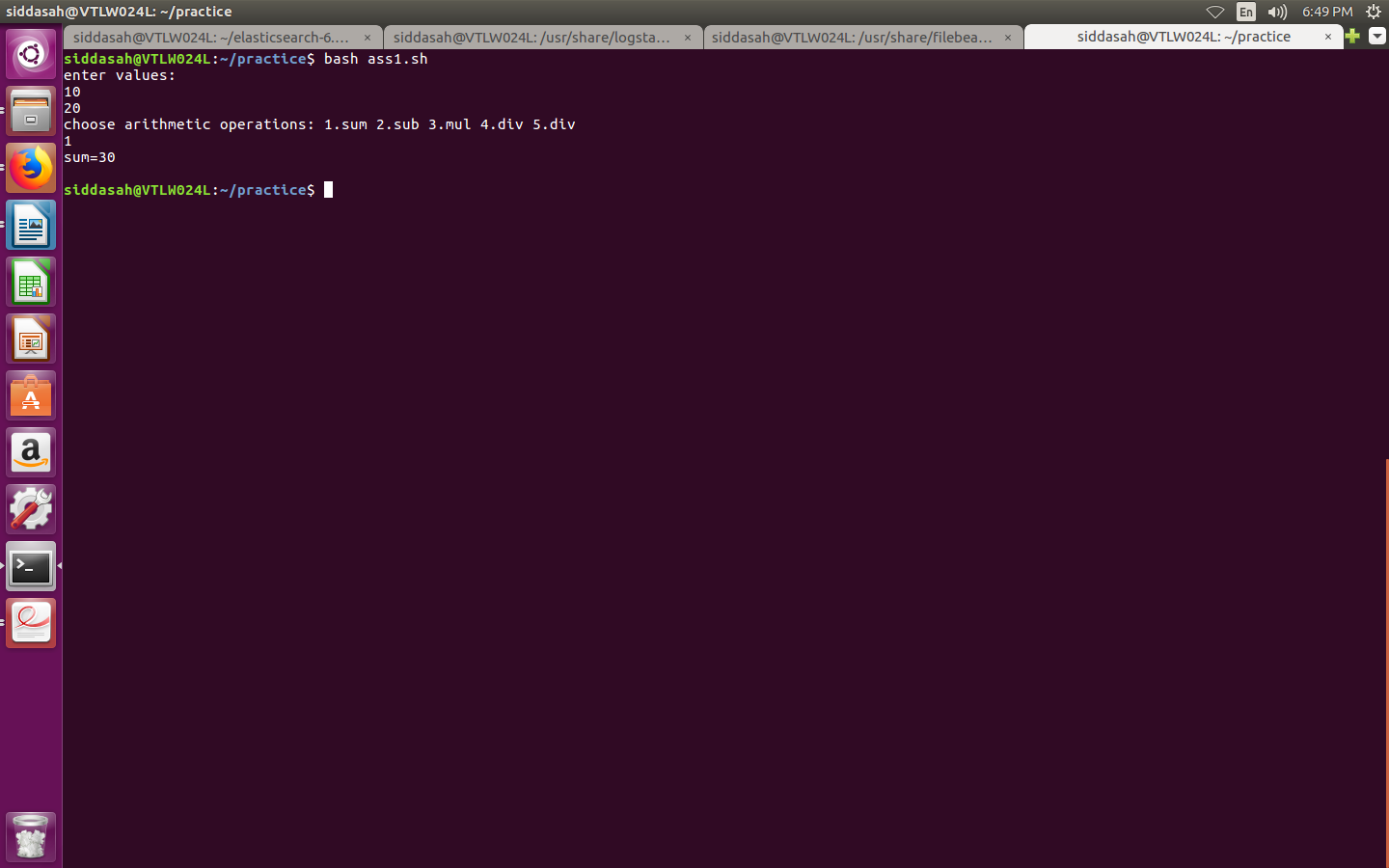

3. shell script to print number of files and sub directories in a specified directory
!/usr/bin/bash
if [ -d "$@" ]
then
find "$@" type -f | ls -l "$@" | wc -l | echo "number of files is: $@"
find "$@" type -d | ls -l "$@" | wc -l | echo"number of directories is : $@"
fi
output:
./sample.sh “directory name”
5. signalling program
#!/bin/bash
#signal_test2.sh
trap exithandler
trap ' '
trap inthandler
Signal Handling
TERM
ABRT
INT
exithandler()
{
echo "Received SIGTERM"
exit 1
}
inthandler()
{
echo "Received SIGINT"
echo "Now making SIGINT to default action"
trap - INT # Restore the "INT" signal handler to the
default action
}
ps -f
cntr=1
echo "Welcome to Signal Handler
Program"
while true ;
do
echo -n $cntr
sleep 3
cntr=`expr $cntr + 1`
echo -n " "
done
output:
